Name - Aparna Bharti

Batch - Data Engineering batch-1

**Day -6**

**Total Aggregation**

**Min()**

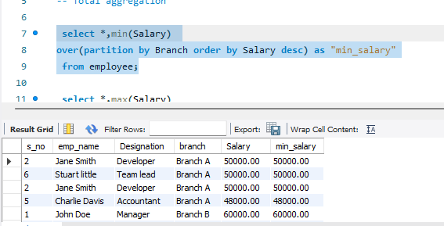

**Max()**

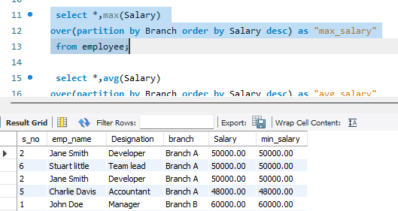

**Avg()**

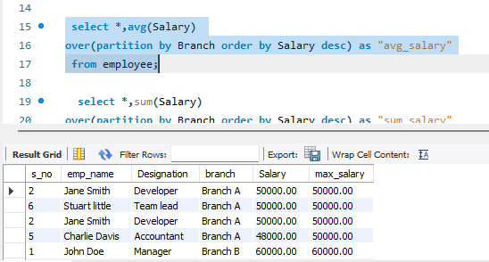

**Sum()**

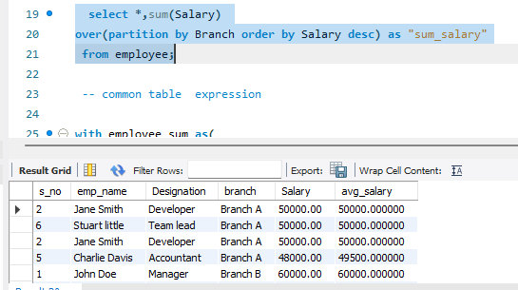

**Common Table Expression**

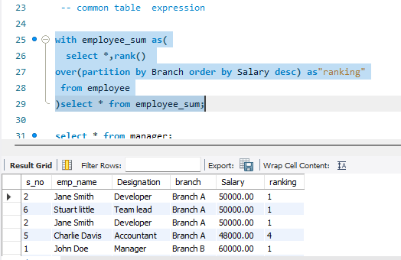

**Recursive Common Table Expression**

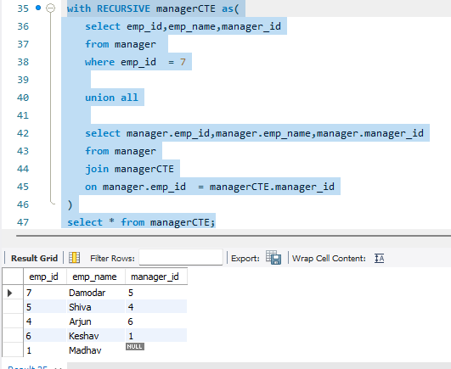

**View**

**Create view**

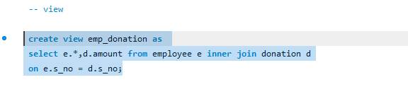

**Alter view**

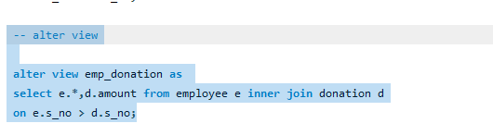

**Rename view**

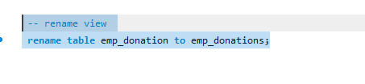

**Drop view**

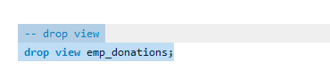

**Materialised view**

**Create Materialised view**

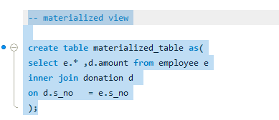

**Update Materialised view**

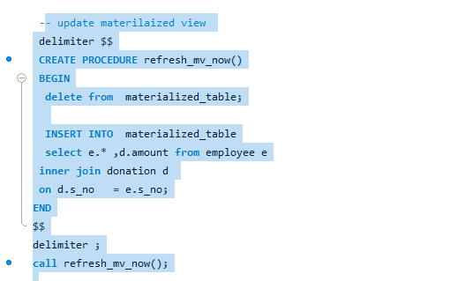

**Hierarchical Queries**

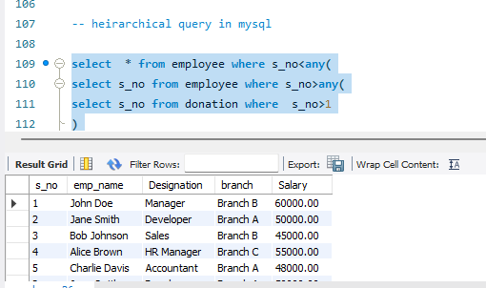

**SubTotal Queries**

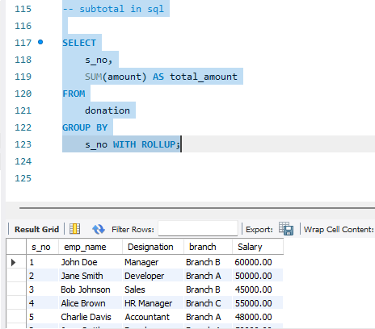

**Regex Queries**

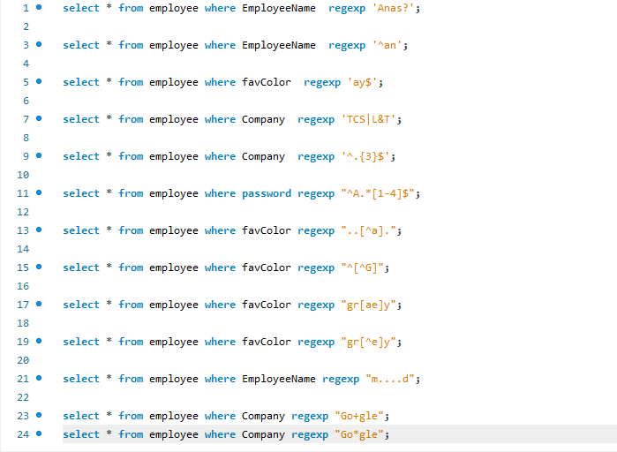

**Snowflaking**

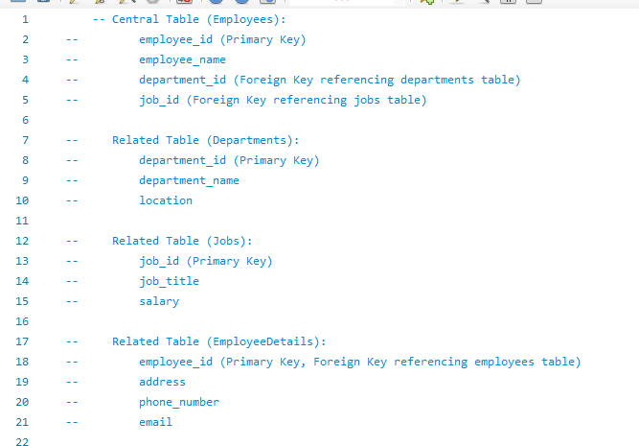

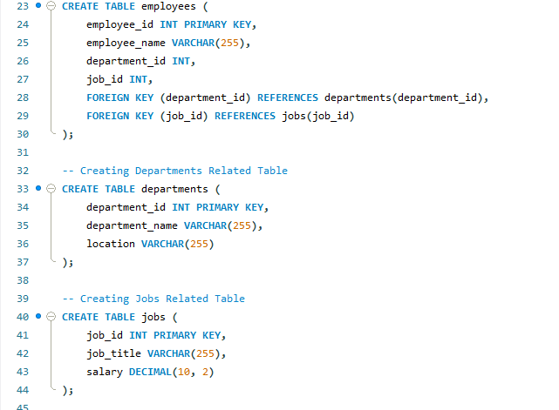

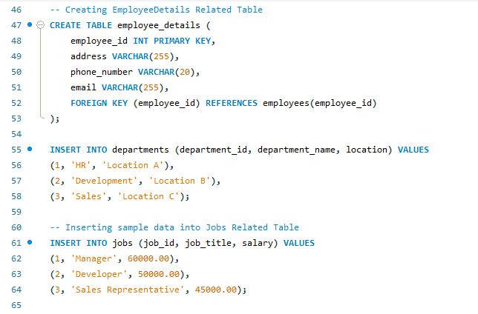

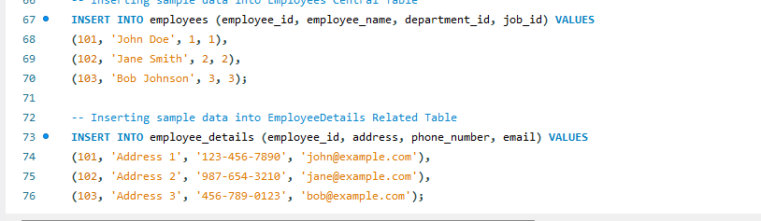

**Star Schema**

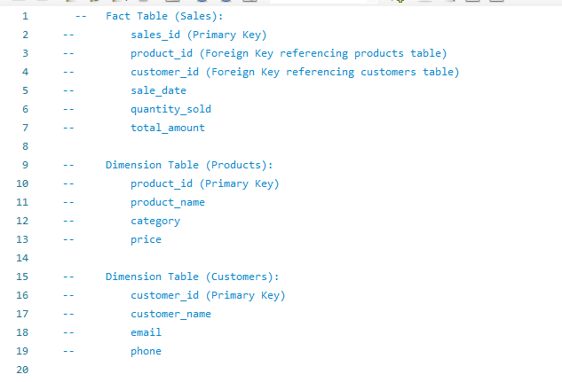

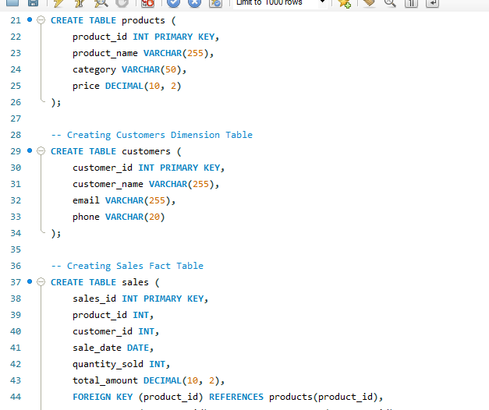

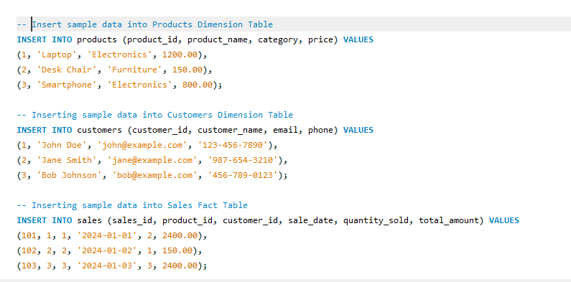

**Set operations**

**Union**

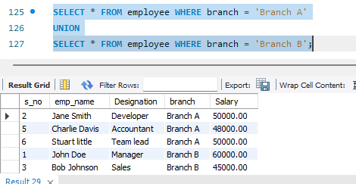

**Except**

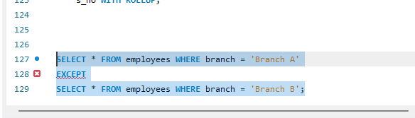

**Intersect**

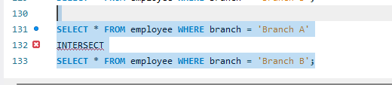

**Rules and Restrictions to Group and Filter**

working with SQL queries, especially those involving GROUP BY and filtering, there are certain rules and restrictions to be aware of to ensure the accuracy and efficiency of your queries. Here are some key considerations:

GROUP BY Clause:

**Columns in SELECT must be in GROUP BY or used with an Aggregate Function:**

Any column in the SELECT clause that is not part of an aggregate function (like COUNT, SUM, AVG, etc.) must be included in the GROUP BY clause.

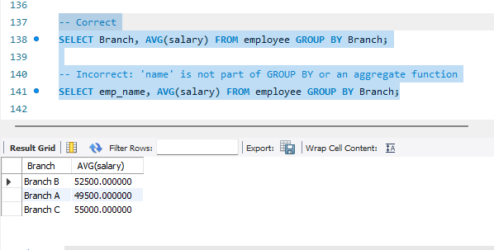

**Aggregate Functions in SELECT without GROUP BY:**

If the GROUP BY clause is not used, all selected columns must be part of an aggregate function.

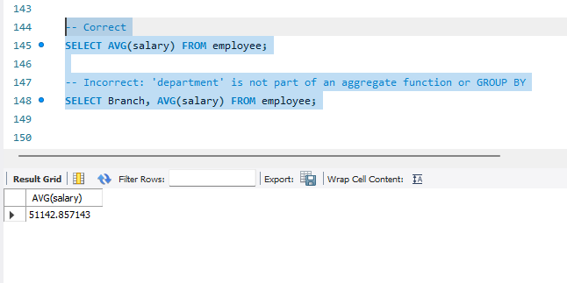

**No Aggregation on Columns Not in GROUP BY:**

You cannot use aggregate functions on columns that are not part of the GROUP BY clause.

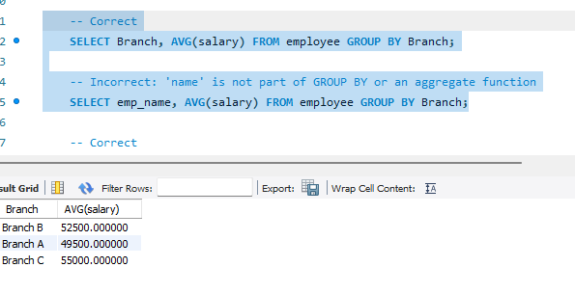

### **HAVING Clause:**

**HAVING is used with GROUP BY:**

The HAVING clause is used to filter the results after grouping. It is similar to the WHERE clause but is used with aggregate functions.

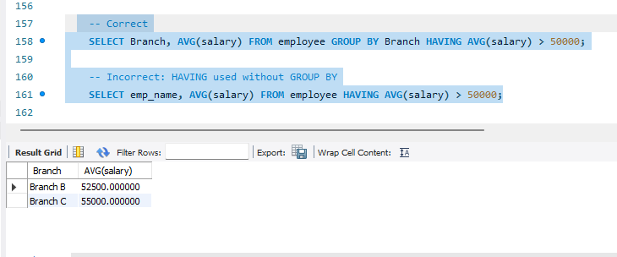

### 

### 

### **WHERE Clause**

**Filtering Rows Before Grouping**

Use the WHERE clause to filter rows before they are grouped.

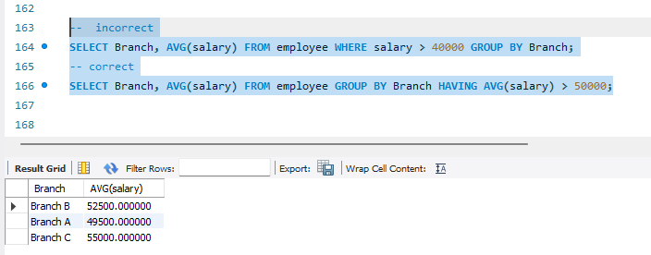

**Filtering After Grouping with HAVING**

Use the HAVING clause to filter results after grouping.

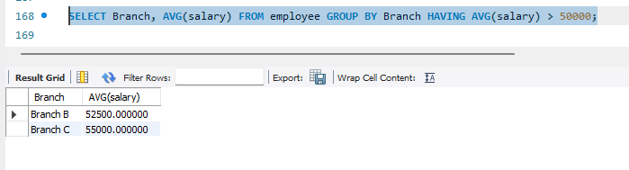

### **General Guidelines**

**Order of Clauses**

The order of clauses in a SQL query matters. Generally, it follows the sequence: SELECT, FROM, WHERE, GROUP BY, HAVING, ORDER BY.

**Avoid Ambiguous Column References**

When using GROUP BY, avoid ambiguous column references by qualifying them with table aliases.

